App comments
Add Report tab
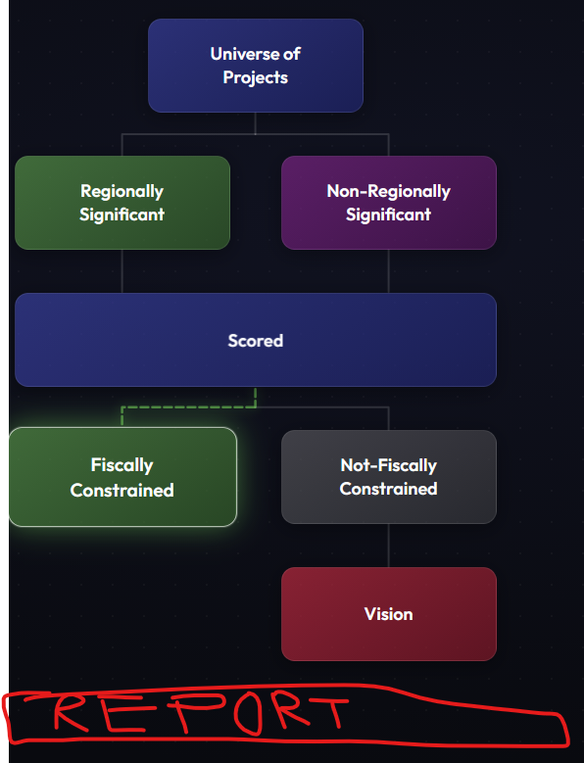
I want you to create areport that uses this data (
Before |  |  |  | -
 | Improvement Type | before_cost | before_count | before_perc
 | Shared Use Path | 314.01 | 21 | 25%
 | Interchange Modification | 272.44 | 20 | 22%
 | Road Widening | 227.69 | 6 | 18%
 | Multimodal Corridor Improvements | 183.92 | 14 | 15%
 | Bicycle & Pedestrian Improvements | 85.54 | 22 | 7%
 |  | 1,241.15
After
 | Improvement Type | after_cost | after_count | after_perc
 | Interchange Modification | 113.74 | 17 | 23%
 | Road Widening | 126.38 | 3 | 25%
 | Multimodal Corridor Improvements | 81.60 | 7 | 16%
 | Replacement/Rehabilitation | 107.81 | 6 | 22%
 | Operational & Safety Improvements | 57.81 | 22 | 12%
 |  | 496.99

) to create something like this.
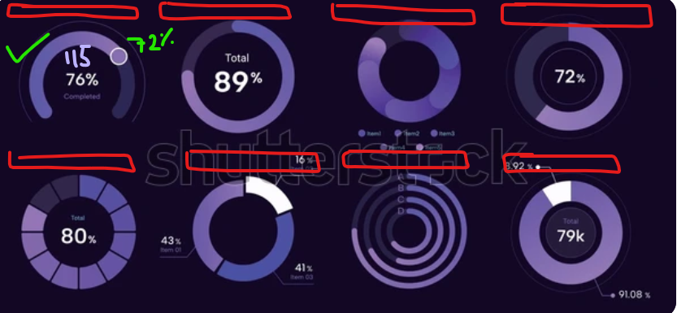
Add a Revenue Utilization (use Revenue_Forecast.xlsx)- for this add a dropdown that selects a Revenue, for example Special Structures, and show table: Special Structures_Original, Special Structures_YOE_90%_Cap, Special Structures_Programmed, Special Structures_Utilization_%.

